**Unit Test definition**

Unit Test (UT) is code written by a developer that verifies the behavior of small element in a software system, which are most often a single class or methods (the unit). Every UT must have several characteristics (F.I.R.S.)

**Fast**: takes a little time to execute

.**Isolated**: does not interact with over parts of as system, failure reasons become obvious. (Inversion of Control, Test Double)

**Repeatable**: run repeatedly in any order, any time.

**Self-Checking**: no manual evaluation required.

**Timely**: written before the code.

**Test is not a unit**

Interacts with over parts of system (DB, API, FS, SMTP, etcs)

Takes to much time to run (more than 0.01sec)

Requires manual setup or verification.

**Unit Test benefit**

Unit test as documentation.

Unit test as safety net (Continues Integration).

Defect localization.

Needless of debugging.

Design improving. (IoC, Refactoring code)

**Ineffective Unit Test**

When does test become a problem, not a solution?

Fragile Test: break too often.

Erratic Test: sometimes it pass and sometimes if fail.

Manual Intervention: a test requires a person to perform some manual action each time it is run.

Obscure Test: it is difficult to understand the test.

Slow Test: test takes too much time to run.

**Types of tests**

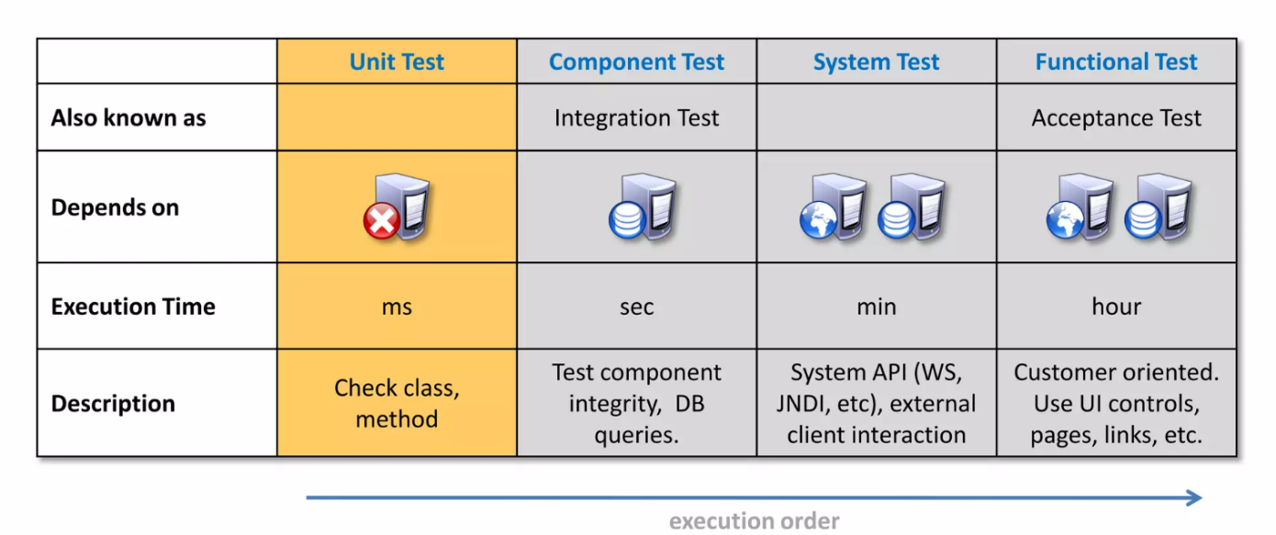

**Test Pyramid**

<https://martinfowler.com/bliki/TestPyramid.html>

